VPC challenge.

Use Case: Setting up Transit Gateway and VPC Endpoints for a Multi-VPC Architecture

Design and deploy a scalable network architecture using AWS Transit Gateway to simplify network connectivity between multiple VPCs.

Created Transit Gateway
Attached multiple VPCs to Transit Gateway
Configured Transit Gateway route tables
Updated VPC route tables to route traffic via Transit Gateway
Enabled communication between VPCs using private IPs
Verified connectivity between instances in different VPCs

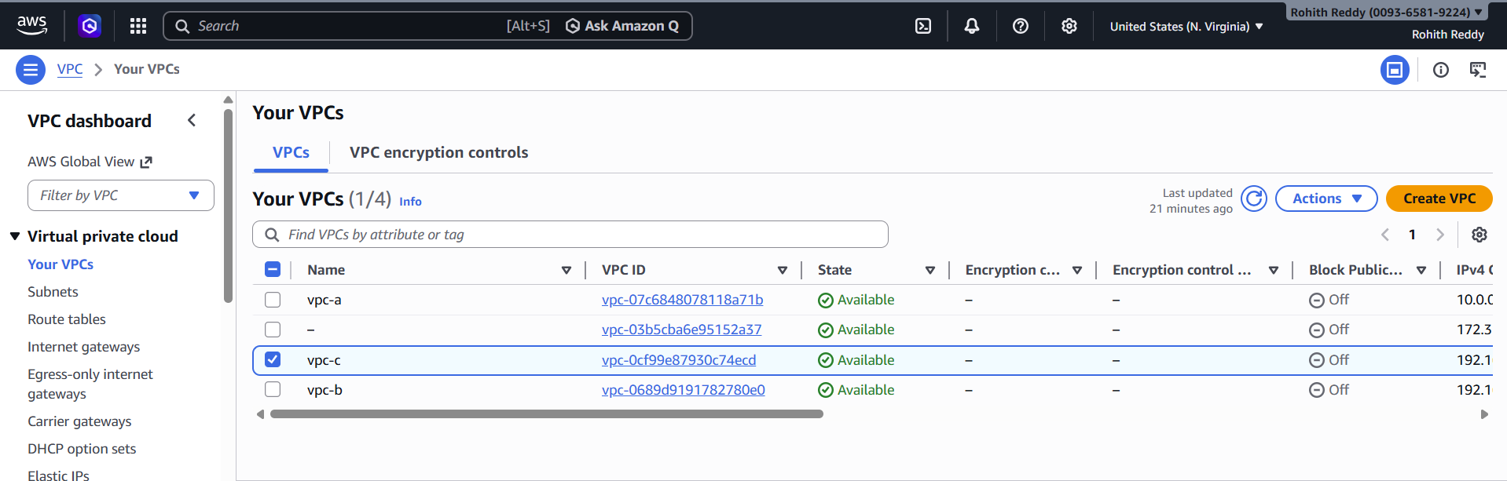

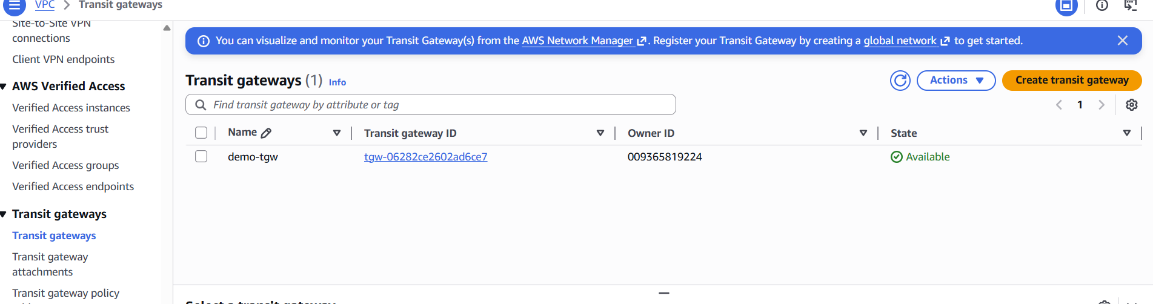

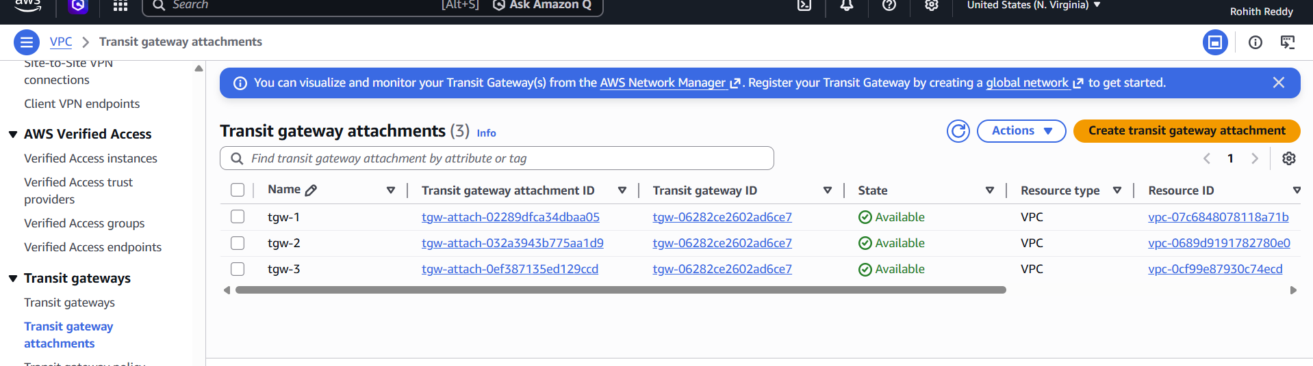

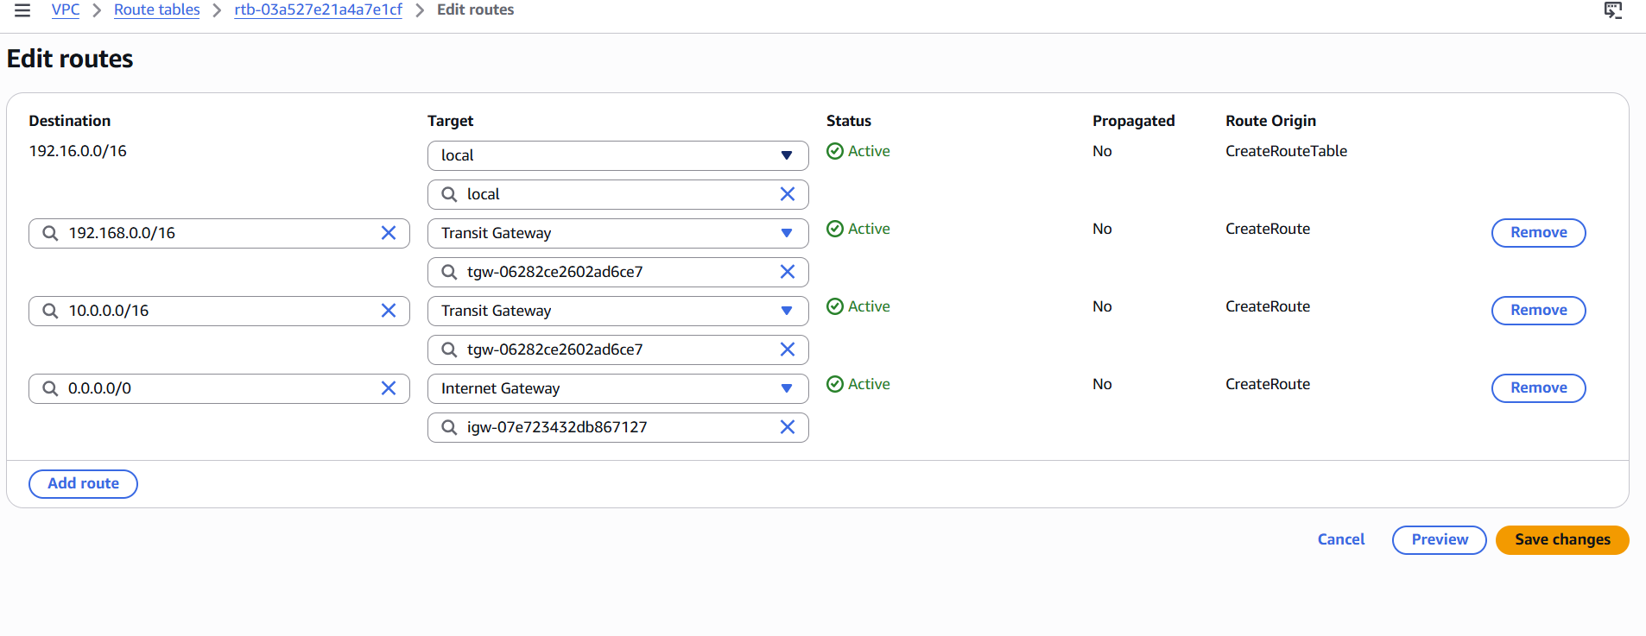

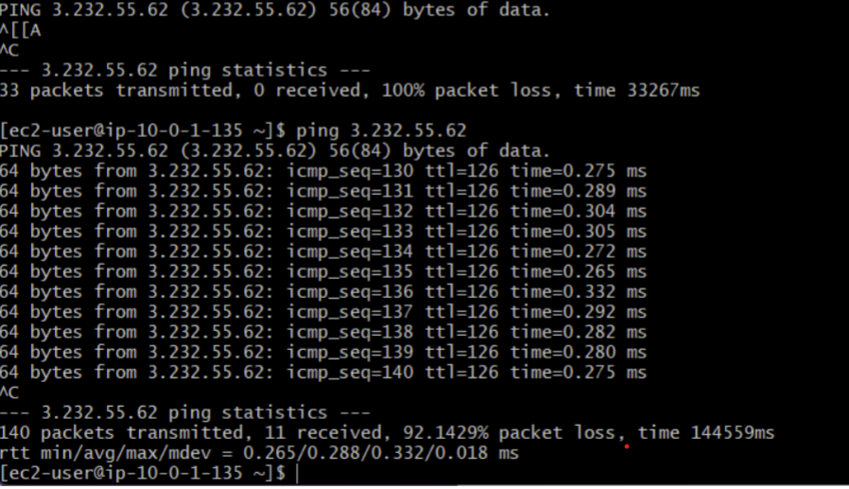
- Configure VPC endpoints to securely access AWS services without internet gateways or NAT gateways, ensuring data privacy and minimizing exposure to external threats.

Created VPC Endpoint for Amazon S3
Selected Gateway type endpoint
Associated endpoint with private route table
Verified route table entries for S3 prefix list
Ensured instances in private subnet can access S3 without Internet Gateway or NAT Gateway

